Project Design Phase-II
Technology Stack (Architecture & Stack)
Date | 28.09.2026
Team ID | __________
Project Name | LegalEase
Maximum Marks | 4 Marks

Technical Architecture
The LegalEase application follows a 3-tier architecture consisting of the Presentation Layer, Application/Business Logic Layer, and Data Layer. The system supports customers, legal professionals, customer care executives, and administrators.
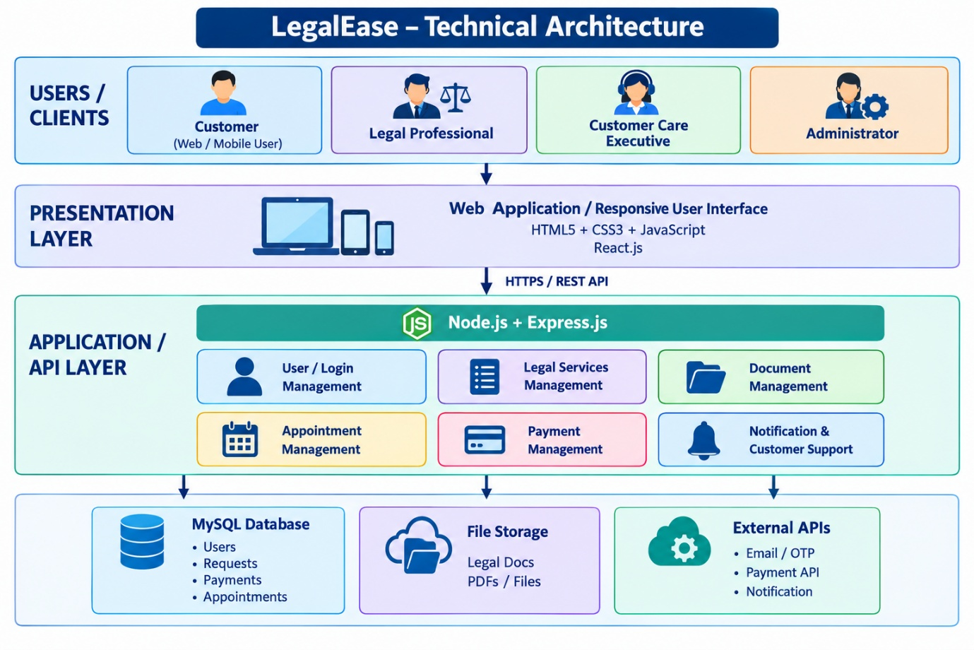
Table-1: Components & Technologies
S.No | Component | Description | Technology
1 | User Interface | Interface through which customers, legal professionals, customer care executives and administrators interact with LegalEase. | HTML5, CSS3, JavaScript, React.js
2 | Application Logic-1 | Handles user registration, login, authentication, legal requests, appointments and business logic. | Node.js, Express.js
3 | Application Logic-2 | Handles document upload, document validation and secure document management. | Node.js / Express.js, Multer
4 | Application Logic-3 | Handles notifications, email confirmation, OTP and customer communication. | Node.js, Nodemailer, OTP Service
5 | Database | Stores structured application data such as users, legal requests, appointments, payments and service information. | MySQL
6 | Cloud Database | Cloud-based database deployment for scalable and remote access to LegalEase data. | MySQL / Amazon RDS
7 | File Storage | Stores uploaded legal documents, PDFs and other files securely. | Amazon S3 / Cloud Storage
8 | External API-1 | Used for online payment processing for legal services. | Razorpay / Stripe API
9 | External API-2 | Used for sending email and OTP notifications to registered users. | Email / SMS API
10 | Machine Learning Model | Optional future component for legal document classification, document categorization and intelligent search. | Python, NLP / Machine Learning
11 | Infrastructure (Server / Cloud) | Hosts and deploys the LegalEase web application and backend services. | AWS / Cloud Server, Docker

Table-2: Application Characteristics
S.No | Characteristics | Description | Technology
1 | Open-Source Frameworks | Open-source technologies are used to develop the user interface, backend and database connectivity. | React.js, Node.js, Express.js, MySQL
2 | Security Implementations | Secure authentication, password hashing, HTTPS communication, role-based access and input validation are implemented to protect user and legal information. | JWT, bcrypt, HTTPS/SSL, RBAC, OWASP practices
3 | Scalable Architecture | LegalEase follows a 3-tier architecture so that the presentation, application and database layers can be scaled independently as the number of users increases. | React.js, Node.js, MySQL, Docker/AWS
4 | Availability | Cloud deployment, database backup and monitoring mechanisms can be used to keep the application available with minimum downtime. | AWS, Load Balancer, Database Backup
5 | Performance | API optimization, database indexing, caching and optimized document handling are used to provide faster response times and support multiple simultaneous users. | Node.js, MySQL Indexing, Redis Cache, CDN

